

Summary for Mr Anthony Barnes
Pre- Existing
TFAS Wealth Ltd
03 December 2025

Recommendation
Investment: £79,066 then £0 monthly

The agreed risk level considered your natural attitude to risk, capacity for loss and required return for your goal.
4
Agreed risk level^{[1]}
[1] As a Cautious Balanced investor you tend to see yourself as quite a cautious person and are inclined to view risk negatively rather than as a source of opportunity. If you have limited or moderate experience of investments and do not find financial matters particularly easy to understand then you may be suited to a Cautious Balanced approach to investing. You may also be suited to this approach if you take some time to make investment decisions and tend to be somewhat anxious about those decisions. As a Cautious Balanced investor you are inclined to look for safer investments, although you may consider taking some risk in exchange for increased potential returns.
The client’s agreed risk level is 4. The 10 year future volatility for the existing holdings based on the current asset allocation is 12.34. This volatility maps to a risk level of 6 which is outside the client’s agreed risk level.
Existing Holdings
12.34  10 Year Volatility^{[2]} | 6  Balanced Growth^{[4]}

[2]Portfolio future volatility is calculated as the standard deviation of the portfolio's simulated future values over a 10 year term using the portfolio's asset allocation. Simulated future values are based on stochastic simulations carried out with return, volatility and correlation projections for the underlying asset classes from Hymans Robertson.
[4] As a Balanced Growth investor you do not see yourself as a cautious person and have no strong positive or negative associations with the notion of taking risk. If you have experience of investments and a degree of understanding of financial matters then you may be suited to a Balanced Growth approach to investing. You may also be suited to this approach if you make investment decisions reasonably quickly and don’t tend to be particularly anxious about those decisions. As a Balanced Growth investor you can be inclined to look for a combination of investments with differing levels of risk and understand that you may need to take some risk to meet your investment goals.
Investment | Provider | % Invested
Vanguard LifeStrategy 80% Equity Fund A Acc (GBP) | Vanguard Investments UK, Limited | 64.95
Vanguard LifeStrategy 60% Equity Fund A Acc (GBP) | Vanguard Investments UK, Limited | 35.02
Cash - Bank Account (GBP) | Cash Account Co | 0.03

MiFID II pre-sale cost disclosure (ex-ante/estimated costs)
The below table illustrates the ex-ante MiFID II pre-sale cost disclosures for funds in scope of MiFID II which excludes Life & Pension funds. One off costs reflect the maximum entry and exit costs that the fund manager has stated they can charge over the period the fund is held. Where costs are on-going, such costs reflect a 12 month period.
One-Off Costs - Maximum costs incurred when entering or exiting the fund. These costs might be waived by the fund manager or distributor. One-Off Costs include: Initial Charge; Maximum Entry Cost Acquired; Maximum Exit Fee; and Maximum Exit Cost Acquired.
Ongoing Costs - The Annual Management Charge and other fund expenses for example, custodian fees; audit fees; legal fees; marketing distribution; and costs of underlying investments.
Transaction Costs - Costs incurred when buying or selling underlying investments. Includes both explicit costs for example dealing commission and can include implicit costs, for example slippage.
Incidental Costs - The impact of any performance fee.
Fund name | One-Off Costs* | Ongoing Costs | Transaction Costs | Incidental Costs | Total
Vanguard LifeStrategy 60% Equity Fund A Acc | - | £61.08  (0.22%) | £10.33  (0.04%) | - | £71.41  (0.26%)
Vanguard LifeStrategy 80% Equity Fund A Acc | - | £113.34  (0.22%) | £13.45  (0.03%) | - | £126.79  (0.25%)
Total aggregated fund costs: | £0.00  (0.00%) | £174.42  (0.22%) | £23.78  (0.03%) | £0.00  (0.00%) | £198.20  (0.25%)
* ’One-Off Costs’ represent the maximum costs that can be incurred when entering or exiting the fund and might be waived by the fund manager or distributor.
Asset allocation

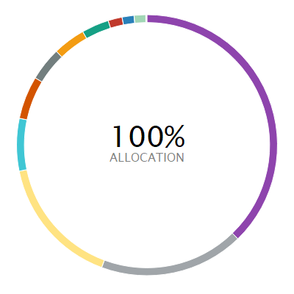 | ASSET ALLOCATION NET %⁽¹⁾ SHORT % LONG %  l North America Equity 37.79 0.00 37.79  l Global (ex-UK) Fixed Income 17.91 -0.01 17.92  l UK Equity 16.18 0.00 16.18  l Europe (ex-UK) Equity 6.51 0.00 6.51  l UK Government Bonds 5.32 0.00 5.32  l Emerging Markets Equity 4.16 0.00 4.16  l Developed Pacific (ex-Japan) Equity 4.03 0.00 4.03  l Japan Equity 3.39 0.00 3.39  l UK Corporate Bonds 1.74 0.00 1.74  l UK Index Linked Bonds 1.48 0.00 1.48  l Other 1.45 0.00 1.45  l Cash - Bank Account 0.03 0.00 0.03
⁽¹⁾ Due to rounding there may be a discrepancy between the Long/Short % and the Net %.

Investment performance
Individual cumulative investment performance graph
The chart shows an investment’s performance, calculated as NAV to NAV/Bid to Bid/Closing Price to Closing Price, with dividends/distributions reinvested, including the effect of ongoing costs and charges. These figures are calculated to the performance date 02 December 2025.
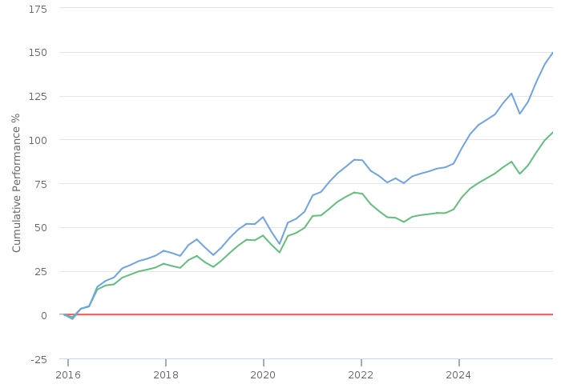
━━ | Cash - Bank Account (GBP) | ━━ | Vanguard LifeStrategy 60% Equity Fund A Acc (GBP)
━━ | Vanguard LifeStrategy 80% Equity Fund A Acc (GBP)

Individual cumulative investment performance table
The table shows an investment’s performance, calculated as NAV to NAV/Bid to Bid/Closing Price to Closing Price, with dividends/distributions reinvested, including the effect of ongoing costs and charges. These figures are calculated to the month end performance date 31 October 2025.
FUND | 3M | 6M | 1YR | 3YR | 5YR | 10YR
Cash - Bank Account (GBP)
Vanguard LifeStrategy 60 Equity Fund A Acc (GBP) | 6.03 | 13.74 | 13.86 | 35.92 | 42.45 | 105.98
Vanguard LifeStrategy 80 Equity Fund A Acc (GBP) | 7.36 | 17.61 | 17.03 | 45.41 | 66.42 | 152.74

Individual discrete investment performance table
The table shows an investments performance, calculated as NAV to NAV/Bid to Bid/Closing Price to Closing Price, with dividends / distributions reinvested, including the effect of ongoing costs and charges. These figures are calculated for calendar years and / or the period within the current year specified.

Existing holdings individual discrete performance data
Fund | 2021 | 2022 | 2023 | 2024 | YTD
Cash - Bank Account | - | - | - | - | -
Vanguard LifeStrategy 60% Equity Fund A Acc | 9.93 | -11.22 | 10.14 | 9.65 | 11.99
Vanguard LifeStrategy 80% Equity Fund A Acc | 14.44 | -8.81 | 11.83 | 13.2 | 14.27

Product

Name | Provider
Pension Portfolio - Choice | Aviva Life & Pensions UK Limited

Platform
Name | Provider
Aviva Platform | Aviva



Research Report for Mr Anthony Barnes
Pre- Existing
TFAS Wealth Ltd
03 December 2025


Contents

Contents 2
Risk profile 3
How are risk levels used to create suitable investment portfolios? 3
Agreed risk level 4
Existing holdings 5
Statistics 5
Funds 5
MiFID II pre-sale cost disclosure (ex-ante/estimated costs) 6
Risk level 7
Combined cumulative investment performance graph 7
Combined cumulative investment performance table 7
Individual cumulative investment performance graph 8
Individual cumulative investment performance table 8
Combined discrete investment performance graph 10
Combined discrete investment performance table 10
Individual discrete investment performance table 10
Combined top ten holding 11
Asset allocation 11
Product selection 12
Selected Research Area 12
Recommended Product 12
Panel 13
Template 13
Filters 13
Shortlist 14
DNA features 15
Platform selection 16
Recommended Platform 16
Panel 17
Template 17
Filters 17
Shortlist 18
DNA features 19
Notes 20

In using this report you acknowledge that nothing in this report is, or shall be deemed to constitute, financial, investment or other advice or a recommendation or endorsement by Defaqto in respect of any product or service referred to herein. Your financial adviser, rather than Defaqto, will provide any such advice, recommendation or endorsement.

Risk profile
This section details how we reached an agreed risk level for this goal. It covers factors including your natural attitude to risk, capacity for loss and required return; factors used when selecting the types of investments and determining suitability.

How are risk levels used to create suitable investment portfolios?
The natural risk level, which is ascertained from the psychometric attitude to risk questionnaire score, is used as a starting point to discuss the actual level of risk you are willing and able to take to meet your specific investment objective.
In the discussion we had, you were shown a projection, based initially on your natural risk level, investment amount, target and desired time horizon. We then discussed this projection and altered any factor, including the risk level, until we agreed that the right balance had been achieved. This resulted in an agreed risk level for the investment.
To project the potential outcomes, each risk level is mapped to a collection of asset classes designed to expose you to an appropriate level of risk. Projections are produced by passing the asset class breakdown for the selected risk level to a stochastic engine that uses modelling provided by Hymans Robertson to project the future performance of the combination of asset classes.
By using these projections and discussions, we came to an agreed risk level for your specific investment objective. A portfolio will be built to meet your agreed risk level.
A summary of the results of this process is documented below.

Agreed risk level
Following an interactive discussion, and considering your natural attitude to risk, capacity for loss and required return for your goal, we agreed a risk level.
4  Cautious Balanced |  | As a Cautious Balanced investor you tend to see yourself as quite a cautious person and are inclined to view risk negatively rather than as a source of opportunity. If you have limited or moderate experience of investments and do not find financial matters particularly easy to understand then you may be suited to a Cautious Balanced approach to investing. You may also be suited to this approach if you take some time to make investment decisions and tend to be somewhat anxious about those decisions. As a Cautious Balanced investor you are inclined to look for safer investments, although you may consider taking some risk in exchange for increased potential returns.

client atr

Existing holdings

Statistics
12.34  10 Year Volatility^{[3]} | 6  Balanced Growth^{[2]}

[3] Portfolio future volatility is calculated as the standard deviation of the portfolio's simulated future values over a 10 year term using the portfolio's asset allocation. Simulated future values are based on stochastic simulations carried out with return, volatility and correlation projections for the underlying asset classes from Hymans Robertson.
[2] As a Balanced Growth investor you do not see yourself as a cautious person and have no strong positive or negative associations with the notion of taking risk. If you have experience of investments and a degree of understanding of financial matters then you may be suited to a Balanced Growth approach to investing. You may also be suited to this approach if you make investment decisions reasonably quickly and don’t tend to be particularly anxious about those decisions. As a Balanced Growth investor you can be inclined to look for a combination of investments with differing levels of risk and understand that you may need to take some risk to meet your investment goals.

Funds
The client’s existing portfolio contains the following funds:
Fund | Provider | ISIN | Diamond rating | Family diamond rating | % Invested
Vanguard LifeStrategy 80% Equity Fund A Acc (GBP) | Vanguard Investments UK, Limited | GB00B4PQW151 |  | N/A | 64.95
Vanguard LifeStrategy 60% Equity Fund A Acc (GBP) | Vanguard Investments UK, Limited | GB00B3TYHH97 |  | N/A | 35.02
Cash - Bank Account (GBP) | Cash Account Co | CASHACCOUNT | N/A | N/A | 0.03
Total Allocation |  |  |  |  | 100%

MiFID II pre-sale cost disclosure (ex-ante/estimated costs)
The below table illustrates the ex-ante MiFID II pre-sale cost disclosures for funds in scope of MiFID II which excludes Life & Pension funds. One off costs reflect the maximum entry and exit costs that the fund manager has stated they can charge over the period the fund is held. Where costs are on-going, such costs reflect a 12 month period.
One-Off Costs - Maximum costs incurred when entering or exiting the fund. These costs might be waived by the fund manager or distributor. One-Off Costs include: Initial Charge; Maximum Entry Cost Acquired; Maximum Exit Fee; and Maximum Exit Cost Acquired.
Ongoing Costs - The Annual Management Charge and other fund expenses for example, custodian fees; audit fees; legal fees; marketing distribution; and costs of underlying investments.
Transaction Costs - Costs incurred when buying or selling underlying investments. Includes both explicit costs for example dealing commission and can include implicit costs, for example slippage.
Incidental Costs - The impact of any performance fee.

Fund name | One-off costs* | Ongoing costs | Transaction costs | Incidental costs | Total
Vanguard LifeStrategy 60% Equity Fund A Acc | - | £61.08  (0.22%) | £10.33  (0.04%) | - | £71.41  (0.26%)
Vanguard LifeStrategy 80% Equity Fund A Acc | - | £113.34  (0.22%) | £13.45  (0.03%) | - | £126.79  (0.25%)
Total aggregated fund costs: | £0.00  (0.00%) | £174.42  (0.22%) | £23.78  (0.03%) | £0.00  (0.00%) | £198.20  (0.25%)
* ’One-Off Costs’ represent the maximum costs that can be incurred when entering or exiting the fund and might be waived by the fund manager or distributor.
The funds data used within Defaqto Engage is sourced from Morningstar UK.
Morningstar UK Data Disclaimer
The data and calculations contained herein are: (i) proprietary to Morningstar; (ii) not warranted to be accurate, complete or timely; and (iii) provided to you by Defaqto Engage at your own risk. You agree that neither Morningstar nor Defaqto Engage is responsible for any damages or losses arising from any use of this information and that the information must not be relied upon by you, the user, without appropriate verification. Morningstar and Defaqto Engage inform you as follows: (i) no investment decision should be made in relation to any of the information provided other than on the advice of a professional financial adviser; (ii) past performance is no guarantee of future results; and (iii) the value and income derived from investments can go down as well as up.
Data and Calculations: © 2025 Morningstar UK. All Rights Reserved.

Risk level
The client’s agreed risk level is 4. The 10 year future volatility for the existing holdings based on the current asset allocation is 12.34. This volatility maps to a risk level of 6 which is outside the client’s agreed risk level.

Combined cumulative investment performance graph
The chart shows the combined investments performance, calculated as NAV to NAV/Bid to Bid/Closing Price to Closing Price, with dividends/distributions reinvested, including the effect of ongoing costs and charges. These figures are calculated to the performance date 02 December 2025.
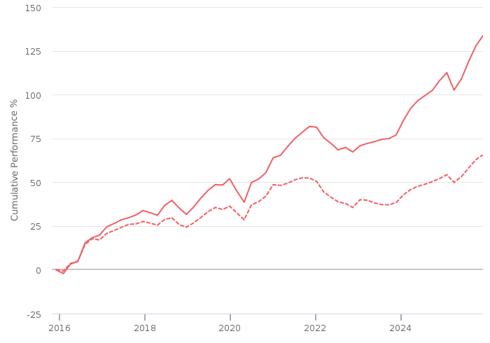
━━ | Combined | --- | Benchmark : Risk Level 4 Benchmark (GBP)

Combined cumulative investment performance table
The table shows the combined investments performance, calculated as NAV to NAV/Bid to Bid/Closing Price to Closing Price, with dividends/distributions reinvested, including the effect of ongoing costs and charges. These figures are calculated to the month end performance date 31 October 2025.
FUND | 3M | 6M | 1YR | 3YR | 5YR | 10YR
Combined Performance (GBP) | 6.89 | 16.25 | 15.91 | 42.07 | 58.01 | 136.32

Individual cumulative investment performance graph
The chart shows an investment’s performance, calculated as NAV to NAV/Bid to Bid/Closing Price to Closing Price, with dividends/distributions reinvested, including the effect of ongoing costs and charges. These figures are calculated to the performance date 02 December 2025.

━━ | Cash - Bank Account (GBP) | ━━ | Vanguard LifeStrategy 60% Equity Fund A Acc (GBP)
━━ | Vanguard LifeStrategy 80% Equity Fund A Acc (GBP)

Individual cumulative investment performance table
The table shows an investment’s performance, calculated as NAV to NAV/Bid to Bid/Closing Price to Closing Price, with dividends/distributions reinvested, including the effect of ongoing costs and charges. These figures are calculated to the month end performance date 31 October 2025.
FUND | 3M | 6M | 1YR | 3YR | 5YR | 10YR
Cash - Bank Account (GBP)
Vanguard LifeStrategy 60 Equity Fund A Acc (GBP) | 6.03 | 13.74 | 13.86 | 35.92 | 42.45 | 105.98
Vanguard LifeStrategy 80 Equity Fund A Acc (GBP) | 7.36 | 17.61 | 17.03 | 45.41 | 66.42 | 152.74

Combined discrete investment performance graph
The chart shows the combined investments performance, calculated as NAV to NAV/Bid to Bid/Closing Price to Closing Price, with dividends/distributions reinvested, including the effect of ongoing costs and charges. These figures are calculated for calendar years and/or the period within the current year specified.
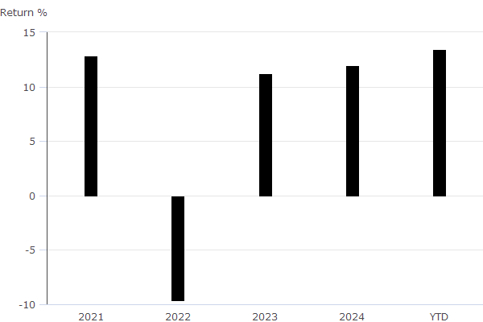

Combined discrete investment performance table

Fund | 2021 | 2022 | 2023 | 2024 | YTD
Combined Discrete Performance (GBP) | 12.86 | -9.65 | 11.23 | 11.95 | 13.47

Individual discrete investment performance table
The table shows an investments performance, calculated as NAV to NAV/Bid to Bid/Closing Price to Closing Price, with dividends / distributions reinvested, including the effect of ongoing costs and charges. These figures are calculated for calendar years and / or the period within the current year specified.

Existing holdings individual discrete performance data
Fund | 2021 | 2022 | 2023 | 2024 | YTD
Cash - Bank Account | - | - | - | - | -
Vanguard LifeStrategy 60% Equity Fund A Acc | 9.93 | -11.22 | 10.14 | 9.65 | 11.99
Vanguard LifeStrategy 80% Equity Fund A Acc | 14.44 | -8.81 | 11.83 | 13.2 | 14.27

Combined top ten holding
The table shows the combined investments top ten holdings for the existing holdings.
Name | Portfolio %
Vanguard FTSE Dev Wld ex-UK Eq Idx £ Acc | 19.48
Vanguard U.S. Eq Idx £ Acc | 18.45
Vanguard FTSE UK All Shr Idx Unit Tr£Acc | 17.60
Vanguard Glb Bd Idx £ H Acc | 15.53
Vanguard Em Mkts Stk Idx £ Acc | 6.00
Vanguard UK Govt Bd Idx £ Acc | 4.67
Vanguard S&P 500 ETF USD Acc | 4.54
Vanguard FTSE Dev €pe ex-UK Eq Idx £ Acc | 3.94
Vanguard UK Invm Grd Bd Idx £ Acc | 2.13
Vanguard Jpn Stk Idx £ Acc | 1.58

Asset allocation

 | ASSET ALLOCATION NET %⁽¹⁾ SHORT % LONG %  l North America Equity 37.79 0.00 37.79  l Global (ex-UK) Fixed Income 17.91 -0.01 17.92  l UK Equity 16.18 0.00 16.18  l Europe (ex-UK) Equity 6.51 0.00 6.51  l UK Government Bonds 5.32 0.00 5.32  l Emerging Markets Equity 4.16 0.00 4.16  l Developed Pacific (ex-Japan) Equity 4.03 0.00 4.03  l Japan Equity 3.39 0.00 3.39  l UK Corporate Bonds 1.74 0.00 1.74  l UK Index Linked Bonds 1.48 0.00 1.48  l Other 1.45 0.00 1.45  l Cash - Bank Account 0.03 0.00 0.03
⁽¹⁾ Due to rounding there may be a discrepancy between the Long/Short % and the Net %.

Product selection
This section details the issues identified as being important to the selection of a product and the other criteria used in selecting the most suitable product.

Selected Research Area
The selected research area is Personal Pension Plan

Recommended Product
No additional justification text has been entered
Product / Provider | Pension Portfolio - Choice  Aviva Life & Pensions UK Limited
Product type | Pension Portfolio - Choice
Profile | The Aviva brand name was launched in July 2002. The group was formed by the merger of CGU and Norwich Union in 2000. CGU came from the merger of Commercial Union and General Accident in 1998.  Aviva provide savings, retirement and insurance to 18 million (as at 31st December 2020) customers in their core markets (UK & Ireland Life, General Insurance: UK & Ireland, General Insurance: Canada).

Panel
The Whole of Market has been used in the product selection.

Template
No template has been used in the product selection.

Filters
The table below lists the filters applied and the feature value for the recommended product.
Feature | Filter | Recommended feature value
No filters were applied | No filters were applied | No filters were applied

Shortlist
1 products from a total of 56 matched the filters applied.
Product name | Provider name | Total DNA for DNA features analysed
Pension Portfolio - Choice | Aviva Life & Pensions UK Limited | No DNA applied

DNA features
Quantitative benchmarking enabling detailed product feature analysis
Defaqto’s unique quantitative Data Numerical Analysis (DNA) helps you benchmark products based on the features they offer.
A value is applied to each feature within a product, helping you filter out products with features that are unsuitable for your client.
No Product DNA analysis was carried out.

Platform selection
This section details the issues identified as being important to the selection of a platform and the other criteria used in selecting the most suitable platform.

Recommended Platform
No additional justification text has been entered
Product / Provider | Aviva Platform  Aviva
Profile | Aviva is the largest insurance group in the UK is also a provider of life and pensions products to Europe.  The Aviva brand name was launched in July 2002. The group was formed by the merger of CGU and Norwich Union in 2000. CGU came from the merger of Commercial Union and General Accident in 1998.  Aviva provide savings, retirement and insurance.

Panel
The TFAS panel has been used in the platform selection.

Template
No template has been used in the product selection.

Filters
The table below lists the filters applied and the feature value for the recommended platform.
Feature | Filter | Recommended feature value
No filters were applied | No filters were applied | No filters were applied

Shortlist
1 products from a total of 4 matched the filters applied.
Product name | Provider name | Total DNA for DNA features analysed
Aviva Platform | Aviva | No DNA applied

DNA features
Quantitative benchmarking enabling detailed product feature analysis
Defaqto’s unique quantitative Data Numerical Analysis (DNA) helps you benchmark products based on the features they offer.
A value is applied to each feature within a product, helping you filter out products with features that are unsuitable for your client.
No Platform DNA analysis was carried out.

Notes
KEY: na = not applicable, ns = not stated, nd = not disclosed
The Data Numerical Analysis (DNA) allows the analysis of data on both a quantitative and a qualitative basis, showing not only who does what, but more importantly, how well they do it. This is achieved by a system of benchmarking or ranking on a 1 to 5 basis called DNA. A score of 1 indicates a weak feature; a score of 5 indicates an excellent feature.

